**ASSIGNMENT NO:04-Group A**

Name:Mrunal R Somankar

Roll No:TCOA46

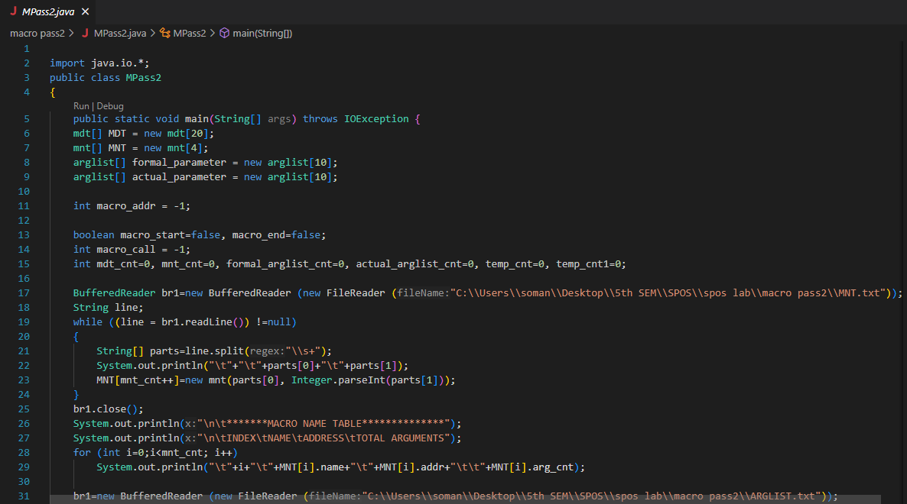

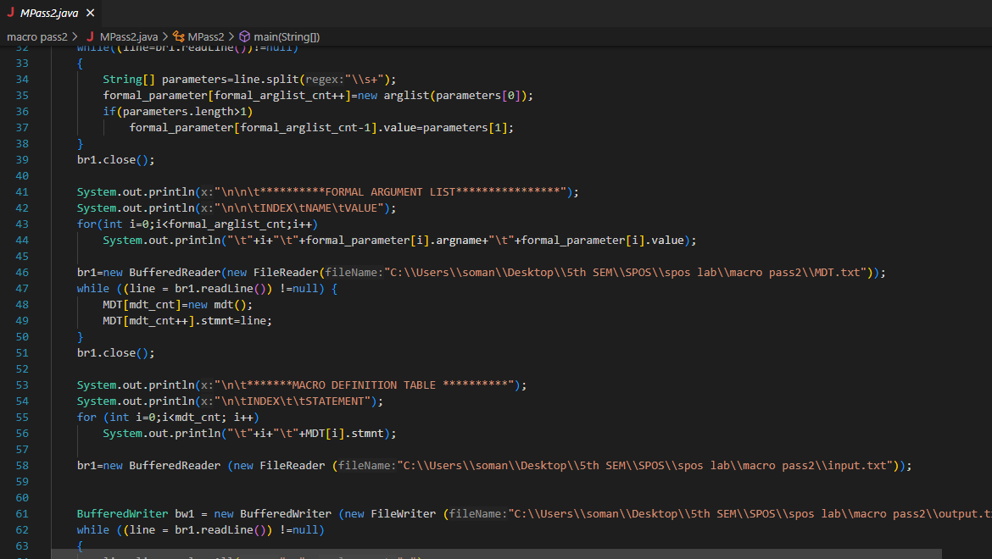

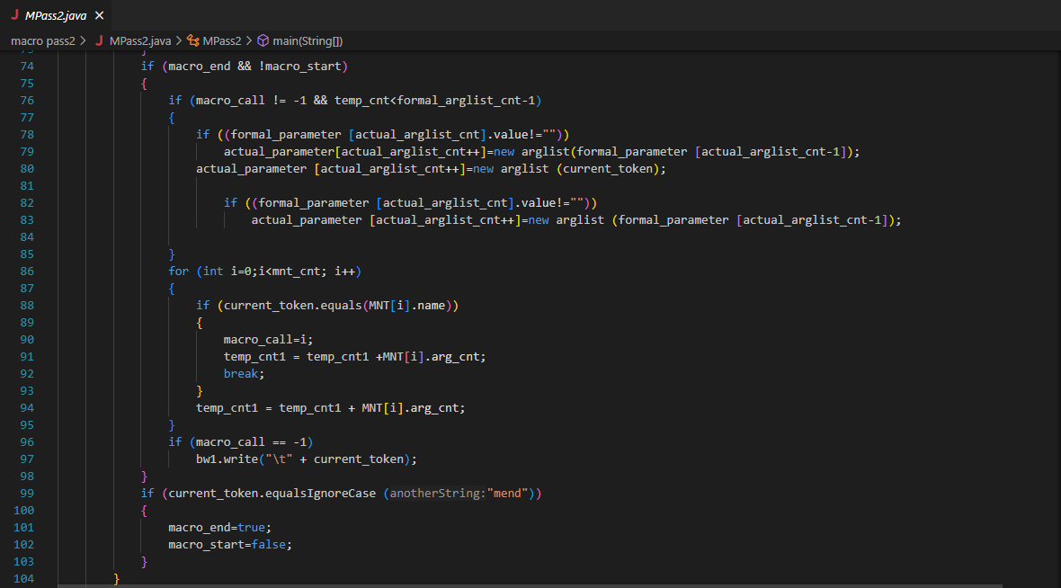

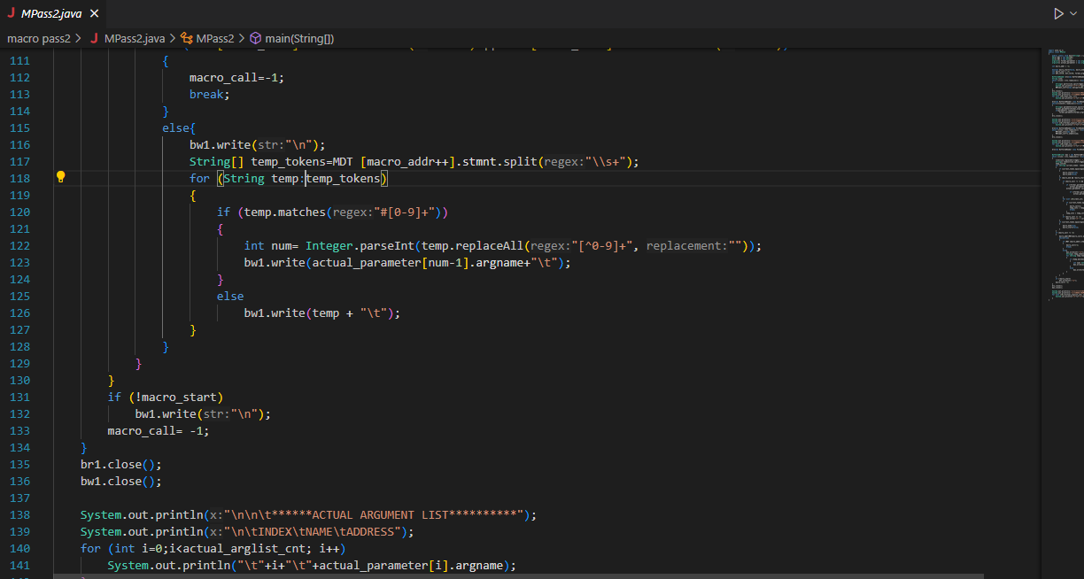

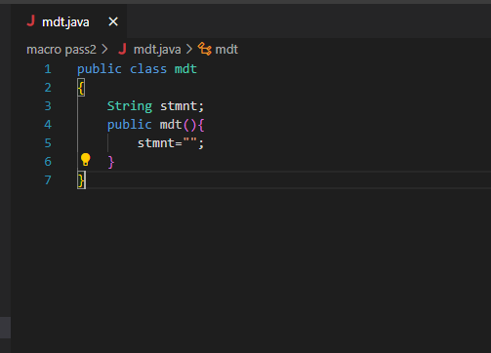

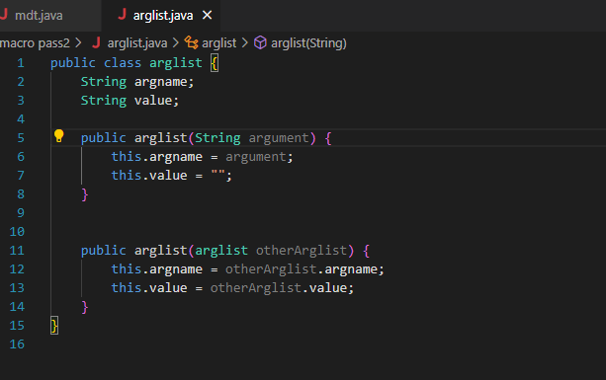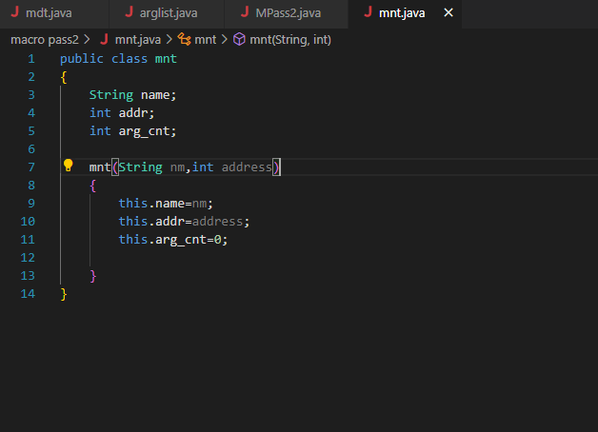

MNT.TXT

INCR    0

DECR    5

ARGLIST.TXT

&X

&Y

&A

&B

INPUT.TXT

MACRO

INCR &X, &Y,&REG=AREG

MOVER &REG,&X

ADD &REG,&Y

MOVEM &REG,&X

MEND

MACRO

DECR &A,&B,&REG=BREG

MOVER &REG,&A

SUB &REG,&B

MOVEM &REG,&A

MEND

START 100

READ N1

READ N2

INCR N1,N2,REG=CREG

DECR N1,N2

STOP

N1 DS 1

N2 DS 1

END

MDT.TXT

INCR    &X  &Y  &REG=AREG

MOVER   #1

ADD #2

MOVEM   #1

MEND

DECR    &A  &B  &REG=BREG

MOVER   #3

SUB #4

MOVEM   #3

MEND

